

Aviation Human Factors Industry News
August 06, 2008

Vol. IV. Issue 30

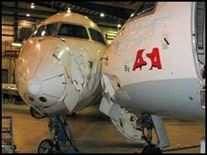
Three planes collide in Baton Rouge, damage in millions
BATON ROUGE, LA (WAFB) - The regional airline, ASA, denied last Wednesday that one of the aircraft involved in a freak hangar accident is to be written off as a total loss. "There has been no such determination by ASA or our engineers working on the event," said Kate Modolo, spokesperson for Atlantic Southeast Airlines.
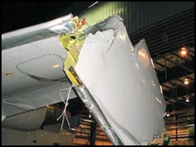
Three CRJ passenger jets sustained serious damage when a young mechanic pressed a starter switch to slowly spin jet engine compressor blades for routine washing. She had successfully performed the same action on the jet's right engine without difficulty. However, mechanics familiar with the accident said that when the mechanic repeated the action on the left engine of the CRJ model 700 jet, a computer control system known as "FADEC" ignited the engine and immediately spun up to near takeoff power. Someone had left the throttle setting for the left engine at 85% power, sources said.
The 34 ton passenger jet leapt forward, plowing into two other CRJ aircraft in the hangar. Airport manager Anthony Marino said the pair of model 200 aircraft that were damaged will be repaired at the Baton Rouge maintenance facility, which employs 120 people. "That's a sign of the high skill levels over there" at the new ASA hangar. Marino was instrumental in construction of the $6 million hangar to lure the ASA maintenance facility to Baton Rouge.

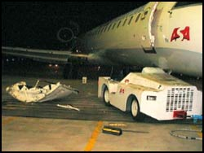
Marino acknowledged that the three-plane smashup could have become an explosive disaster. The incident occurred in the pre-dawn hours of Monday, July 7th. None of the 14 ASA mechanics and cleaning workers inside the hangar was injured. The 1:50 a.m. incident produced little media attention until WAFB News learned of the magnitude of the accident on Monday, July 21st.
ASA spokeswoman Modolo said the investigation of the accident is still underway. Ordinarily, any damage that renders an aircraft not flyable requires a report to the National Transportation Safety Board. However, the NTSB told WAFB News it was not investigating the ASA incident. The aircraft carried no passengers, were not in flight, and were damaged in an FAA-approved maintenance facility.
Together, the three jets are valued at $50 million, according to Modolo. The young woman who set the multi-million dollar chain of events in motion is not likely to bear full blame for the event. "There's plenty of blame to go around," said one airport employee familiar with the accident. While ASA would not discuss its specific safety policies, airliners inside repair hangars ordinarily are drained of most of the fuel and circuit breakers pulled on equipment that could set the engines in motion.
The 60-foot run of the CRJ 700 at near full takeoff power was just 300 yards from normally busy Plank Road on the east perimeter of Baton Rouge airport. The CRJ 700 jet ordinarily carries 70 passengers. The CRJ 200's usually have 50 seats. ASA was purchased from Delta Airlines in 2005 and sold to Air West. ASA has a fleet of 160 aircraft, most of which are CRJ's. The name is derived from the name bombardier Canadair Regional Jet. FAA records show that the most severely damaged plane is actually owned by Wachovia Bank, a common situation in airline financing of their equipment.

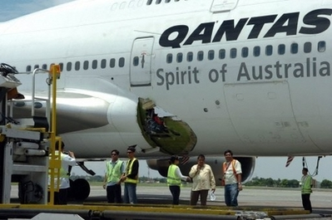
Domestic aircraft included in Qantas maintenance review

THE Civil Aviation Safety Authority (CASA) announced on the weekend the safety and maintenance procedures of the entire Qantas fleet of aircraft would be under review over the coming weeks.
The announcement was made in the wake of a third mid-air incident involving the company’s Boeing 767 aircraft and a month after The Leader was alerted to an

alleged major maintenance oversight at its Tamworth heavy maintenance facility which resulted in work to the fuel lines in five of its Dash 8 aircraft being rechecked after being serviced by a Tamworth engineer.
Two of the Dash 8s were found to have loose fuel sensor lines while a third was not connected at all.
“The review is across the Qantas fleet and it will look at all safety issues, safety management and safety procedures of the company’s domestic and international operations,” CASA spokesperson Peter Gibson said.
“People in regional areas can rest assured maintenance for domestic operations are also being looked at closely.”
Mr Gibson said the decision to undertake a review was taken by the authority’s chief executive, Bruce Byron, after talks with Qantas.
Plane makes emergency landing at Sea-Tac Sunday
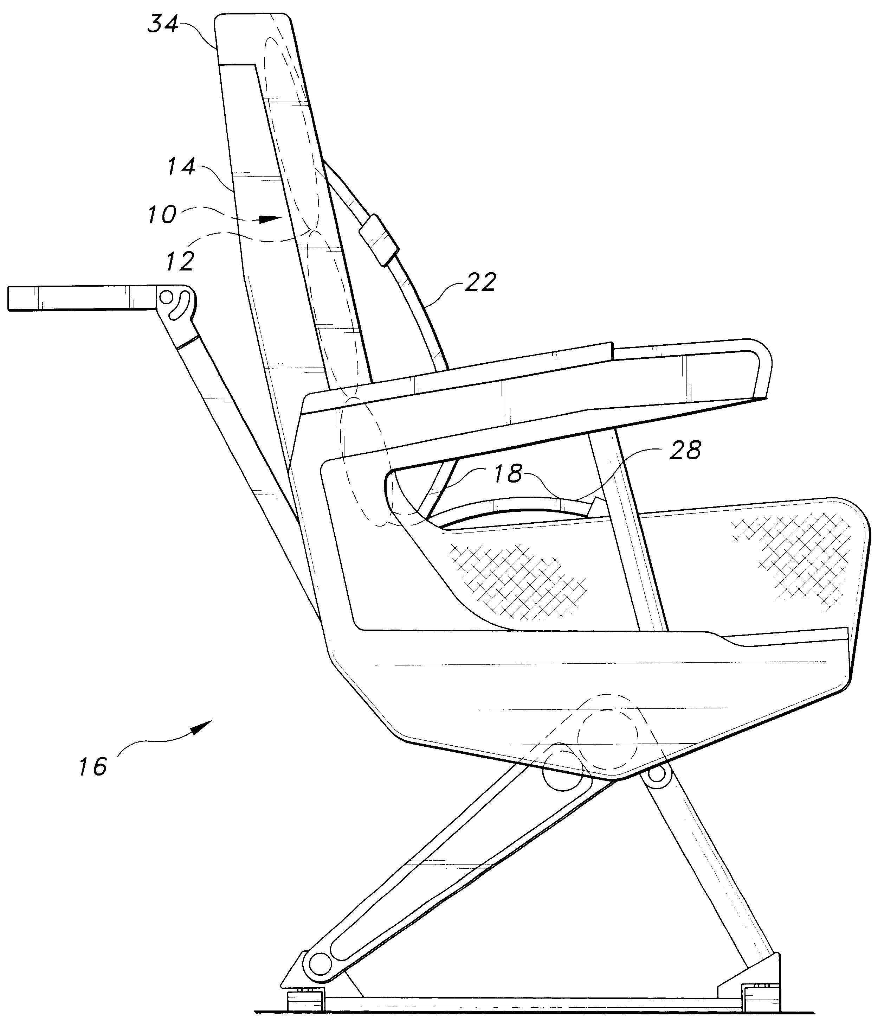
A 61-year-old woman suffered minor injuries Sunday night when authorities describe as a poorly-bolted airline seat slid backward during takeoff and injured her knees.
United Airlines flight 1139 took off as scheduled at 5:20 p.m., but made an emergency landing after Row 3 slid backwards.
An airline maintenance crew discovered the loose bolt and the plane bound for San Francisco took off again at 8:56 p.m. United spokeswoman Robin Urbanski said.
The people in Row 3 were family members of the woman who was apparently injured in Row 4, Urbanski said. They all flew to San Francisco Monday morning "in first class."
Though the incident was minor, the Federal Aviation Administration is expected to give a report on the accident to the National Transportation Safety Board late this month, spokesman Mike Fergus said.
"In the meantime, maintenance logs will be checked as we try to determine how this circumstance came about," he said.
The woman was taken to Highline Medical Center with cuts on her knees, Sea-Tac International Airport spokesman Perry Cooper said. She was transported as a precaution.

Pilots ignore alerts over faulty planes

Engineers say a fault needing attention occurs in about one in every 20 flights
Airlines across Europe are flying planes with known defects because pilots routinely fail to report faults when they find them, an investigation has revealed.
A survey of aircraft maintenance engineers, whose work covered flights to and from the UK, found many pilots only reported faults such as brake fluid leaks and loss of cabin pressure after their homebound flight or after the day's flights. The delay allowed airlines to fix faults at a more convenient time, avoiding extra expense.
On average, 80 to 90 per cent of faults were reported after a pilot had made a homebound flight or after the end of the day's flying schedule. The same picture emerged across major and budget airlines.
Engineers say a fault needing attention occurs in about one in every 20 flights. Planes can fly with certain faults but the extra precautions needed to ensure that they can travel safely cannot be taken if the concerns go unreported.
The organization behind the investigation said that the Helios airliner crash in 2005, when a Boeing 737 crashed into a Greek hillside, killing all 121 on board, was partly caused by a failure to report a fault.
In a catalogue of errors in the run-up to the crash, the pilots failed to record an error in resetting a crucial air-conditioning switch. Soon after the airliner took off from Cyprus, the crew and passengers passed out because of a lack of oxygen.
Aircraft Engineers International (AEI), the global body of 45,000 aviation maintenance engineers, asked its members to make voluntary inspections of airliner logbooks, containing all information on a plane's faults and when they were reported. One engineer examined 40 logbooks involving more than 3,000 flights, and found that 90 per cent of defects were reported after the homebound flight or at the end of the day. Precise data on the flights involved could not be released, the AEI said, because it feared doing so would put the jobs of the engineers who contributed the data in jeopardy. It now hopes its survey will prompt Europe's aviation regulators to carry out their own random checks of logbooks to stamp out late reporting.

Fred Bruggeman, the AEI's secretary general, said: "We are positive that if regulators examined logbooks in the way we have, they will discover exactly the same pattern of late reporting. Their shocking lack of response makes it clear to us that they do not want to open Pandora's Box. We fear regulators had become too cozy with the aviation industry and are not taking our safety concerns seriously enough."
The UK's aviation regulator, the Civil Aviation Authority (CAA), said it carried out inspections of logbooks and was satisfied with its safety measures. Richard Taylor, a spokesman, said: "The AEI have been making these claims for some time, but they have so far failed to provide us with specific examples. We have carried out our own checks and have found no discrepancies. If they do have any documentary evidence that anyone is failing to report faults, they have a duty to pass on this information to us.
Information can be passed to us in complete confidence." But Robert Alway, head of Alea, which represents 2,000 maintenance engineers in the United Kingdom, said that his members had come under pressure from employers for revealing fault data.
"The CAA and other European regulators must have a look for this irregular reporting pattern themselves," he said. "If they do, we are in no doubt they will find the same irregular reporting pattern."
Frank Taylor, an air accident investigator, said that the logbook check had uncovered a "worrying finding". He said: "Aircrafts can fly for a limited period with certain items out of service.
If that is used responsibly, it is a sensible system. But the problem starts if that system is abused, or if an airline is deliberately falsifying the accounts by flying back with something which is not on that list, or two things which individually might be OK, but together put it outside the bracket. Economics are so powerful in the aviation industry that it is possible airlines would ignore things they shouldn't ignore."
The budget airline Ryanair said it had not seen the pattern of reporting AEI alleged but that it was "aware that it was a problem for other airlines". Virgin Atlantic said that, as a long-haul carrier, pilots reported after each flight because crews were replaced after each trip. British Airways said that its own safety inspectors had not found that faults were disproportionately being reported at convenient times – and that its safety checks were in accordance with EU regulations. "Our pilots report any defect as soon as it is found," a spokeswoman said. "Ultimately, we would not operate an aircraft if we believed it was not safe."

Balpa, which represents British pilots, said members were doing nothing wrong. Carolyn Evans, head of flight safety, said: "Planes are allowed to fly with certain minor defects and pilots make their report at the end of their operations for the day. For any major faults, the aircraft is grounded straight away."

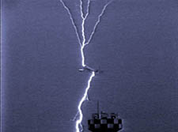
American Gives Mechanics More Leeway in Lightning Checks
Faced with criticism from some safety experts and federal regulators, American Airlines has decided to give its mechanics greater leeway to inspect jetliners for damage in cases of suspected lightning strikes.
The revised procedures cap months of internal debate and discussions with the Federal Aviation Administration about balancing safety considerations with efforts to keep a lid on maintenance costs and flight delays.
The compromise worked out with the FAA seeks to eliminate arguments over lightning-strike inspections -- a flashpoint for labor tensions at the country's largest airline.
The latest checks replace pared-down maintenance practices that went into effect last year. An American spokesman said the airline "met with local FAA officials in May and agreed on mutually acceptable revisions." The changes initially apply only to Boeing Co.'s widebody 767 aircraft used on over-water routes, but the FAA said American plans to phase them in on the rest of its planes.
An FAA spokesman said the changes are intended "to better define what the criteria" will be for conducting abbreviated or more-detailed inspections to look for possible lightning damage. The agency plans to "continually review and monitor" American's practices, he said, and "advise them if there are any shortcomings."
The previous procedures only allowed mechanics to conduct extensive lightning-strike inspections when pilots of an incoming aircraft officially alerted mechanics of a suspected strike, making it difficult for mechanics to initiate inspections between flights.
Critics had questioned American's decision last year to forgo such thorough safety inspections, arguing that pilots -- with their limited view from the flight deck -- often can't tell if their airplane has been struck by lightning. American officials told the FAA that retaining a system in which mechanics have broad authority would continue to subject the carrier to harassment by a small group of activist union members.

According to people familiar with the situation, airline officials became concerned about repeated flight cancellations and delays on international flights departing from New York's John F. Kennedy Airport, where dozens of flights were delayed. During one six-month period last year, people familiar with the situation say that nearly half of the company's 62 lightning-strike reports world-wide occurred at JFK. In a number of cases, the airplanes tagged for inspection had already been inspected and cleared by maintenance.
The new policy restores inspection authority to mechanics, but it also establishes guidelines about what types of damage warrant a full inspection. For example, if a mechanic notices only small or minor fuselage damage, no more than a limited inspection is immediately required. Any repairs can be postponed to regularly scheduled maintenance periods when the plane is taken out service anyway.
If there are signs of more extensive fuselage damage -- or lightning is suspected of hitting a flight-control surface or other critical system -- a range of more time-consuming inspections will again be required before further flight.

NTSB Wants Fixes To Airbus Cockpit Electronics
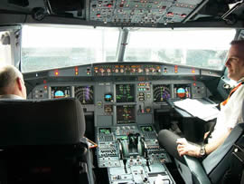
49 Reported Cases Of Dark Displays In Recent Years

Few would argue that so-called "glass cockpits" are a major leap forward in cockpit management and crew safety... until those panels go dark in-flight, which the National Transportation Safety Board says has
happened at least 49 times in recent years onboard several Airbus airliners.

On Wednesday, the NTSB issued five recommendations to address concerns about cockpit displays going inop on Airbus A319 and A320 narrowbodies. Of the 49 incidents reported to the Board, seven involved all six cockpit displays going blank at once... something safety experts once thought was all-but impossible.

Sixteen planes lost five of the six cockpit displays. In addition to flight instruments and engine monitoring systems, loss of the avionics displays also resulted in the loss of comm., systems, transponders, and traffic advisory systems.

In January of this year, a United A320 had to make a hasty return to Newark Liberty, when the captain's primary flight display (PFD) and navigational display (ND), along with the upper electronic centralized aircraft monitoring (ECAM) display, went blank on takeoff. The plane was able to make a safe emergency landing, helped greatly by the fact conditions were VMC.

The NTSB notes the first officer's ND remained functional, as did the lower ECAM display. The first officer also reported that the attitude information on his PFD was initially not usable, but that the information appeared to be reliable later in the flight.

Those circumstances were similar to those experienced onboard a British Airways A319 three years before, which suffered failures to five of six cockpit displays while cruising at FL200 from London to Budapest. Most of the screens returned within 90 seconds.

British investigators have already issued safety recommendations related to the problem and Airbus issued a safety bulletin in May 2007 recommending new wiring fixes and increased crew training on how to handle electrical systems failures. But those fixes aren't mandatory, and the NTSB says they should be.

Included in the six recommendations from the NTSB are calls for a backup power supply to be added to the standby attitude indicator, and the automatic reconfiguration of the AC essential bus power supply in the event that the AC 1 electrical bus fails. The NTSB also wants greater crew training, and additional simulator time for pilots to learn how to handle such failures.

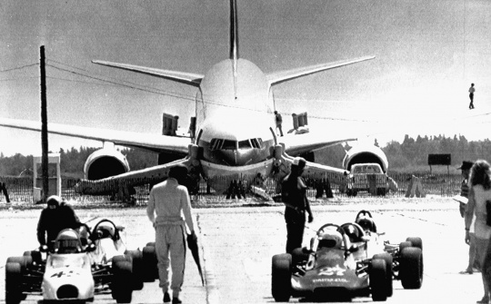
Pilot who glided 767 to miraculous Gimli landing returns to scene, hailed as hero

Gimli, Manitoba — An Air Canada Boeing 767, nicknamed the Gimli Glider, dwarfs race cars using an abandoned airstrip as a race track in this 1983 file photo. The Boeing was forced to glide to an emergency landing after it ran out of fuel at 40,000 feet.

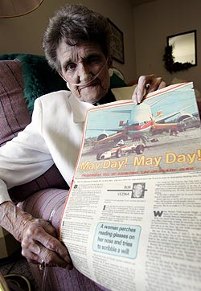
Aldis Douglas, 86, holds a July 31, 1983 tear sheet from the Edmonton Sun which documented the Gimli glider incident at the Whispering Waters Seniors Lodge, 5303 - 47 Street, Stony Plain.

Art Zuke can still picture the huge Boeing 767 barreling straight at him and his two young friends, its nose grinding along an abandoned airstrip in Gimli, Man., firing off sparks and smoke.
Twenty-five years later, he will finally get a chance to thank the plane's pilot, Bob Pearson, whose heroic actions, he says, prevented dozens of people from being killed.
"The plane really couldn't have gone 300 feet farther than it did without mowing down things, myself included," Zuke said this week in an interview with The Canadian Press. "People would have been killed for sure."
Last Wednesday marks the 25th anniversary of the emergency landing of what has become known fondly as the Gimli Glider, an Air Canada 767 that had left Montreal and Ottawa for Edmonton with 69 passengers and crew on board.
The jet ran out of fuel 40,000 feet over northern Ontario - partly thanks to a mix-up over the newly adopted metric system - and lost engine power.
With no chance of making it to Winnipeg, Pearson was left with one option - try to glide the massive aircraft to the little-known, abandoned airstrip in Gimli, about 100 kilometers north of Winnipeg, which had been converted to a drag strip for race-car enthusiasts.
"We were airborne for something like 20 minutes without engine power," Pearson recalled this week from his farm in eastern Ontario.
Both engines were dead and only a limited number of flight instruments were functioning on backup battery power. One of the instruments that weren’t working was the vertical speed indicator, which tells a pilot how fast a plane is dropping.
On the ground, 14-year-old Zuke and two friends were riding bicycles at the far end of the drag strip. He was the first to see the plane approach and he knew immediately that something was wrong.
"Just to see that sort of an airliner coming into the Gimli area was surreal, and to see it come in completely silently ... was an amazing sight," he said.
"We were fixated on this plane coming in, like a deer fixated on the headlights of a car coming at it."
The plane was coming in too high to land safely at the drag strip, which was roughly one kilometer long, so Pearson reached back to his days as a glider pilot. He used a maneuver called a side slip to increase the aircraft's drag and bring it down more quickly.
"It was falling out of the sky much like you see the space shuttle coming out of the sky, losing altitude very quickly," Zuke said.

"We didn't move. It was ... an unbelievable thing to see."
The plane passed over a golf course. One passenger was reported to have said he could read the writing on people's golf clubs.
Seconds later, the rear wheels touched the runway. Pearson slammed on the brakes, blowing out two tires. He wasn't at all sure he could bring the jet to a halt before he ran out of runway.
Then, as the front of the plane touched down, things got worse.
"The nose gear collapsed and the nose hit with quite a thump, and I looked up and there were these boys pedaling frantically to the side of the runway," Pearson recalled.
"I knew I couldn't take the airplane into them, so I was prepared to take it off (the runway) into the eastern side."
The teenagers had clued in that they were in danger and were starting to rush to get out of the way.
"It was heading directly at us," Zuke said.
The boys scrambled as the plane skidded toward them, grinding against the pavement and sending off a shower of sparks.
In the cockpit, Pearson was close enough to see the lads' faces as he struggled to halt the plane.
"Looking up and seeing, especially two boys, I remember the look of horror. It must have been pretty terrifying for them."
Suddenly, it was over. The aircraft had screeched to a stop 100 meters from the boys and the end of the drag strip.
"The emergency chutes popped out of the plane and people were leaping out, horrified," Zuke said. "There was some fire at the nose of the plane, just from the friction of the nose pushing itself along the tarmac."
Incredibly, no one on the plane or the ground was injured. Pearson was hailed as a hero for the landing, and for stopping the plane before it could crash into buildings and trailers beyond the end of the drag strip, where people had gathered to watch cars race on nearby tracks.
In the ensuing chaos, as people ran to and from the plane, Zuke and Pearson didn't cross paths. That will change Wednesday, when the two will take part in an anniversary ceremony in Gimli.

"I'm looking forward to shaking (Pearson's) hand and thanking him, because had it not been for him and for the copilot and their amazing skills, certainly nobody would have survived this, on the plane or on the ground," Zuke said.
The crash was blamed on a series of errors, including a faulty fuel measurement processor that didn't work before takeoff. It forced crews to rely on manual calculations for the plane's fuel requirements. There was a computation error, as someone converting imperial gallons to the new metric system used the wrong formula. As a result, the big jet was loaded with only about half the fuel required to make it to Edmonton.
The event led to a federal public inquiry, which cited deficiencies in airline procedures.
Pearson, who retired in 1993, was initially disciplined by Air Canada along with co-pilot Maurice Quintal. The disciplinary measures were withdrawn following a union grievance.
NTSB PRESS RELEASE

************************************************************

MASTER'S POOR DECISION LED TO GROUNDING OF PASSENGER VESSEL EMPRESS OF THE NORTH, NTSB DETERMINES

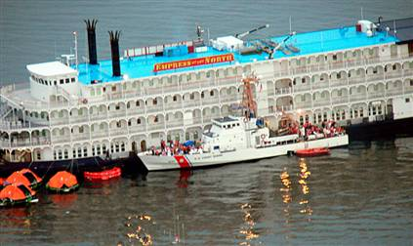
************************************************************

The National Transportation Safety Board has determined that the probable cause of the grounding of the Empress of the North was the failure of the officer of the watch and the helmsman to navigate the turn at Rocky Island,

which resulted from the master's decision to assign an inexperienced, newly licensed junior third mate to the bridge watch from midnight to 4:00 a.m. The third mate was not familiar with the route, the vessel's handling characteristics, or the equipment on the vessel's bridge.

"The flawed decision making in this accident created the potential for a catastrophic disaster," said NTSB Chairman Mark V. Rosenker. "Those in leadership positions need to make sure they consider every option possible when making critical decisions that could put lives at risk."

On May 14, 2007, the 300-foot passenger vessel Empress of the North, operated by Majestic America Line, grounded on a charted rock at the intersection of Lynn Canal and Icy Strait in southeastern Alaska, about 20 miles southwest of Juneau. The vessel was negotiating a turn west out of Lynn Canal into Icy Strait on its way to Glacier Bay, the next stop on a 7-day cruise, carrying 206 passengers and 75 crewmembers. The vessel struck the rock, known as Rocky Island, which was illuminated by a flashing green navigation light.

Passengers and crewmembers were evacuated safely without injuries. The vessel sustained damage to its starboard underside and propulsion system.

In the report adopted yesterday, the Board noted that because of the senior third mate's illness, the master replaced him with the new junior third mate for the midnight-to-4:00 a.m. watch. The third mate held an unlimited, any-ocean third officer's license but had never before stood watch on the vessel or traveled the waters of Lynn Canal.

The master had ample time to consider the watchkeeping assignment, the Board stated. However, the Safety Board investigators found no evidence that the master considered other options and did little to prepare the junior third mate for his first underway watch.

The third mate lacked any knowledge of the route and should not have been left to make this critical maneuver on his own, the Board said.

The Safety Board concluded that the master jeopardized the vessel's safety by allowing the third mate to stand a bridge watch before he was familiar with the route and the bridge equipment.

As a result of its investigation of this accident, the Safety Board recommended that state and U. S. maritime academies use the circumstances of the accident to teach students about their responsibilities as newly licensed officers. The Safety Board also recommended that the Passenger Vessel Association inform its members about the circumstances of the accident.


A synopsis of the Board's report, including the probable cause and recommendations, is available on the NTSB's website, www.ntsb.gov, under "Board Meetings." The Board's full report will be available on the website in several weeks.


Farnborough AirShow

The Raptor makes its European debut

http://www.militarytimes.com/multimedia/video/20080714_rc_f22/



The Road Home
In another ASRS report, an Air Carrier Captain was confronted with several roadblocks to his attempts to park his air craft for the night:
- [We were] cleared to the gate and advised to power in to the gate. Guide-in man had no lights or wands, but was standing in bright lights from the terminal. He brought us 12 feet too far forward of the stop line, and the left engine cowl hit the jetway. When the jetway driver tried to move the jetway, he pushed the aircraft, causing more damage. The stop lines were marked, but were hard to read because they had oil and grease on them. The jetway was not parked in the normal spot and was unlit.
The reporter makes several suggestions for these problems: taxi and parking lines should be clean and visible; jetways should be manned by qualified personnel and parked in proper position; and supervisors should be at any gate where aircraft are being moved. Equipping guide-in personnel with lights or wands is another safety recommendation.

You Just Have a Bad Day

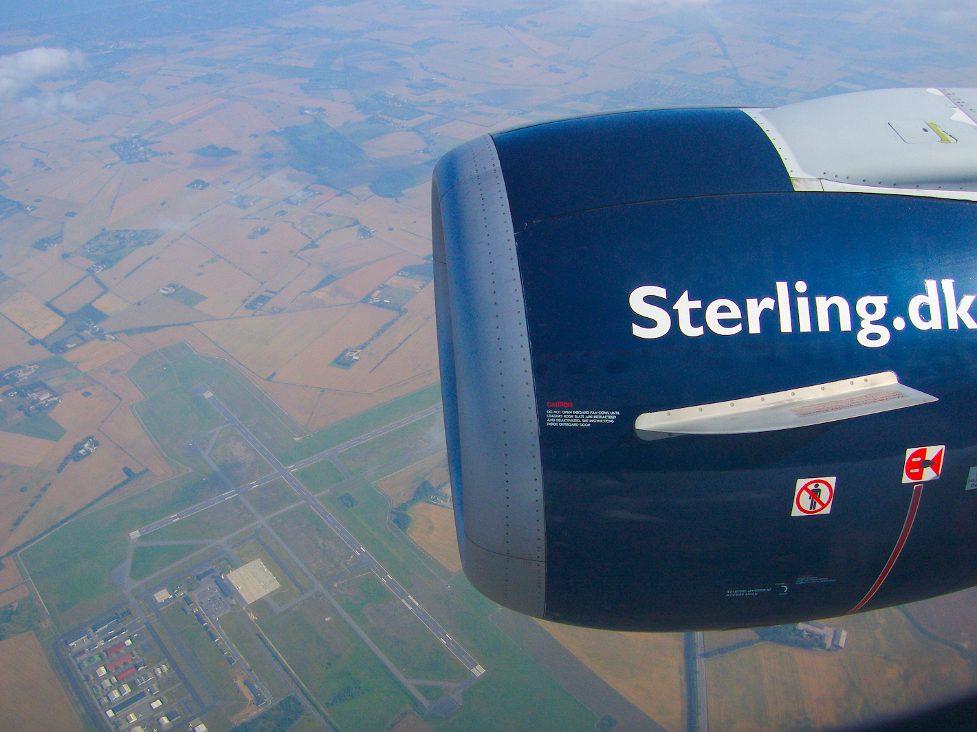
A Sterling Boeing 737 ended up in an unnatural position (for a 737) at the airport in Malaga, Spain last Saturday after a strange encounter with the airport bridge. For some reason, the bridge went up and caught the aircraft under its open door. Early reports didn't have a damage estimate. Click here to download the video directly.

Vintage Aircraft Wings Recovered From Metal Thieves
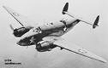
Thieves were apparently in search of scrap metal when they made off with two irreplaceable vintage aircraft wings from a storage yard used by the Wingspan Aviation Heritage Foundation in Mesa, Ariz. When the theft was discovered, about a week ago, foundation director Robert Kropp went to the media in hopes of uncovering information about the wings' fate -- and he got lucky.

An anonymous tipster led Kropp and police directly to both wings, hidden in two separate remote locations in the desert.
"I really feel like I found a winning lottery ticket in the street," Kropp told The Arizona Republic. "I'm just absolutely elated. Without the media exposure, it was gone, baby, gone." The wings, from a 1940s-era Lockheed T-33 trainer and a 1950s Lockheed PV-2 bomber, were found intact and police dusted them for fingerprints.
The wings now are secured in a locked location, and the foundation plans to reattach them to their aircraft as soon as possible and improve security. "It was a big learning curve to see how insidious these metal thieves are," Kropp told the Republic. "I really was so fortunate
Compressed Air: It's a Blast!
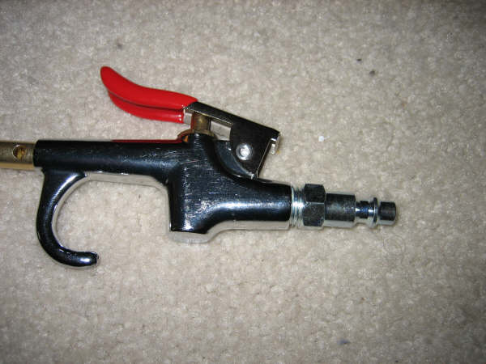
You shouldn't dare poke fun with air. Many workers in all sorts of different fields work with or around compressed air. We use it to power tools, lift loads and do many other jobs that require mechanical forces to be applied. But that's just it, the force in the line is no different from the force at the end of the tool. And your workers should always remember that, which is why you'll want them to get this safety talk.
Compressed air mishaps usually involve abuse, misuse or inattention to hoses or nozzles. Lack of attention to safety or not knowing the proper procedures when handling compressed air have led to many accidents and deaths.
Compressed air can strike you blind, deaf or dead at very low pressures.
These may sound like harsh words, but they are not. Compressed air is something we use in so many different ways, almost without thinking. We have to remind ourselves to handle this power source with care and attention.
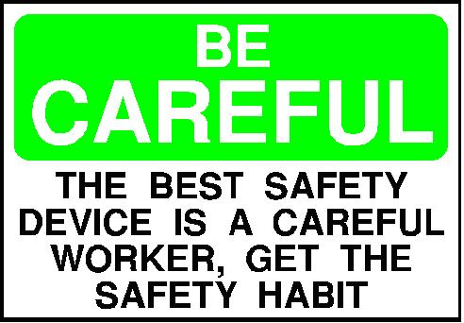
Take the time to learn about compressed air in your workplace and how to use it. Talk to your supervisor about its dangers and where to locate company procedures that will tell you how you must handle compressed air.
Here are some safety suggestions:
- Use the correct personal protective equipment, including safety eyewear when handling compressed air.

- When not in use, store hoses in a cool place and protect them from the elements.
- Don't use hoses that are longer than necessary. Longer hoses can be easily damage or kinked. The longer the hose, the greater the risk of rupture.
- Check all air hoses for cracks or bubbles, at least once daily.
- Test any hoses that show signs of wear or damage. Conduct the testing according to your company's safety procedures.
- Have leaks properly repaired immediately. Never attempt to block a leak with your hand. Never use tape to repair the hose. This is not only ineffective, it's unsafe.
- Do not aim or point compressed air nozzles at yourself or another person.
- Do not use compressed air to blow dust off clothing.
- Never use industrial compressed air in a supplied air respirator.
- When changing tools, turn off the air supply and depressurize the line. Make sure all connections are tight before turning the air pressure back on.
- Ignoring or not understanding all the risks associated with compressed air could cause death or serious injury to you or a co-worker. Is it worth the risk?
What Makes 100%?

What Makes 100%? What does it mean to give MORE than 100%? Ever wonder about those people who say they are giving more than 100%? We have all been to those meetings where someone wants you to give over 100%. How about achieving 103%? What makes up 100% in life?

Here’s a little mathematical formula that might help you answer these questions:

If:
A B C D E F G H I J K L M N O P Q R S T U V W X Y Z is represented as:
1 2 3 4 5 6 7 8 9 10 11 12 13 14 15 16 17 18 19 20 21 22 23 24 25 26.
Then:
H-A-R-D-W-O-R-K
8+1+18+4+23+15+18+11 = 98%
and
K-N-O-W-L-E-D-G-E
11+14+15+23+12+5+4+7+5 = 96%
but
A-T-T-I-T-U-D-E
1+20+20+9+20+21+4+5 = 100%
and
B-U-L-L-S-*-*T
2+21+12+12+19+8+9+20 = 103%
and look how far groveling will take you
G-R-O-V-E-L-L-I-N-G
7+18+15+22+5+12+12+12+9+14+7 = 121%

So, one can conclude with mathematical certainty that while Hard work and Knowledge will get you close, and Attitude will get you there, it’s the Bulls**t and Grovelling that will put you over the top.


Midnight Shift Nugget

Exercise

Whether you’re 9 or 90, abundant evidence shows exercise can enhance your health and well-being. But for many people, sedentary pastimes, such as watching TV, surfing the Internet, or playing computer and video games, have replaced more active pursuits.

What exercise can do for you?

Millions of Americans simply aren’t moving enough to meet the minimum threshold for good health — that is, burning at least 700 to 1,000 calories a week through physical pursuits.

The benefits of exercise may sound too good to be true, but decades of solid science confirm that exercise improves health and can extend your life. Adding as little as half an hour of moderately intense physical activity to your day can help you avoid a host of serious ailments, including heart disease, diabetes, depression, and several types of cancer, particularly breast and colon cancers. Regular exercise can also help you sleep better, reduce stress, control your weight, brighten your mood, sharpen your mental functioning, and improve your sex life.

Exercise at a glance
In a nutshell, exercise can:


>reduce your chances of getting heart disease. For those who already have heart disease, exercise reduces the chances of dying from it.
>lower your risk of developing hypertension and diabetes.
>reduce your risk for colon cancer and some other forms of cancer.
>improve your mood and mental functioning.
>keep your bones strong and joints healthy.
>help you maintain a healthy weight.
>help you maintain your independence well into your later years.

A well-rounded exercise program has four components: aerobic activity, strength training, flexibility, and balance exercises. Each benefits your body in a different way.

Fighting disease with aerobic activity

Aerobic exercise is the centerpiece of any fitness program. Nearly all of the research regarding the disease-fighting benefits of exercise revolves around cardiovascular activity, which includes walking, jogging, swimming, and cycling. Experts recommend working out at moderate intensity when you perform aerobic exercise. This level of activity is safe for almost everyone and provides the desired health benefits. Additional health benefits may flow from increased intensity.

Protecting bone with strength training

Strength or resistance training, such as elastic-band workouts and the use of weight machines or free weights, are important for building muscle and protecting bone.

Bones lose calcium and weaken with age, but strength training can help slow or sometimes even reverse this trend. Not only can strength training make you look and feel better, but it can also result in better performance of everyday activities, such as climbing stairs and carrying bundles.

Stronger muscles also mean better mobility and balance, and thus a lower risk of falling and injuring yourself. In addition, more lean body mass aids in weight control because each pound of muscle burns more calories than its equivalent in fat.

Ease back pain with flexibility exercises

Stretching or flexibility training is the third prong of a balanced exercise program. Muscles tend to shorten and weaken with age. Shorter, stiffer muscle fibers make you vulnerable to injuries, back pain, and stress. But regularly performing exercises that isolate and stretch the elastic fibers surrounding your muscles and tendons can counteract this process. And stretching improves your posture and balance.

Preventing falls with balance exercises

Balance tends to erode over time and regularly performing balance exercises is one of the best ways to protect against falls that lead to temporary or permanent disability. Balance exercises take only a few minutes and often fit easily into the warm-up portion of a workout. Many strength-training exercises also serve as balance exercises. Or balance-enhancing movements may simply be woven into other forms of exercise, such as tai chi, yoga, and Pilates.

** Get your copy of Exercise: A program you can live with
Exercise: A program you can live with is a newly revised Special Health Report from Harvard Medical School. This report describes specific types of exercise and explains the complementary roles of structured exercise and daily activity. It will also help guide you through starting and maintaining an exercise program that suits your abilities and lifestyle.
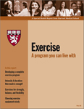
You’ll find advice on being a savvy consumer when it comes to fitness products and equipment, as well as useful tools and tips designed to help make exercise work for you. Click here to read more or buy online.
To order online, click one of the following links:
- Purchase printed version ($16.00)
- Purchase electronic download (PDF) ($16.00)
- Purchase print + electronic download (PDF) ($24.00)


EMERGENCY PREPAREDNESS

Be Ready for Anything, at Work and at Home
So while you're readying your workplace for the worst that nature or humans can throw at you, have you thought about emergencies at or near your home?

Disaster can strike at any time, not just between eight and five on weekdays.
Here are three simple steps to make sure your home and family can ride out rough times:

1. Have an Idea of the Risks
It makes little sense to prepare for flooding if you live atop a mountain in the desert. Evaluate the dangers you might face. Do a little research. For example, if your home's near an industrial area, check local newspaper archives for toxic spills, leaks and fires. Check what the weather can get up to, no matter where you live.

2. Have a Plan
Keep it simple, and ensure everyone knows what part they play in your home emergency plan. Encourage everyone to keep a small "grab-and-go" bag of nonessential stuff you may not have in your family kit (a book, a game, etc.). Everyone should have a list of contacts, including at least two out-of-state-or-province numbers: Disasters can mess up communication within a fairly large area.

3. Have a Kit
Be prepared to survive at least three days in your home without power or access to fresh water. It may take workers that long to get to you. For a real "suspenders-and-belt" approach, plan for a week. You'll need food and water for your whole family (don't forget pets) for the whole period.
Plan on packing at least the following items, and make sure you pack them so that they can be carried out if you have to leave your home:
- Water. You can live two to eight weeks without food, but only about three days without water. You'll need two pints (or liters) per day per person, minimum. You'll want to have it in several containers: Water for four people for three days would weigh 50 pounds (24 kilos).
- Food. Another essential. Pack stuff that will keep. Freeze-dried or dried foods are easy to prepare, save weight and space, and last a long time in storage. But remember - you need to add water in order to cook them.
- Canned food is easy and quick (provided you remember to pack a can opener) but heavy to carry. Try to strike a balance between the two.
- A crank-powered flashlight and radio. A shortwave radio is a nice option to have, as you can hear broadcasts from much farther away than AM or FM. Crank power means never having to worry about batteries.
- Medical supplies. Pack a good first-aid kit. And be sure to pack extra prescription items, such as asthma inhalers and glasses, if you or your family will need them.
- Documentation. You'll need ID and cash at a minimum. An emergency credit card may be useful if you have to leave. Pack smaller bills, say $10, and coins (for pay phones etc.).
Remember to give each family member a copy of your emergency plan, and keep one in your kit. Your plan should detail where to rendezvous, how long to wait, who to contact, and where to go if you have to leave. Keep a two-person emergency kit in your car(s) as well.
Preparedness is your big advantage in a crisis. Your family will get through the hard times more easily if you're ready for them. Remember to update your supplies at least once a year and medicines more often if necessary.

PICTURE THIS!
It may give you a lift right now, but it might also let you down unexpectedly. Like many shortcuts, this one involves misusing equipment for an unintended purpose, and that's inherently dangerous. Would you trim your toenails with an axe? Not only that, but this guy isn't wearing PPE. No fall arrest and no hardhat. Take a look; you'll be glad this dude doesn't work on your jobsite. It's a shame the operator of this equipment seems to have a lax safety attitude, too.




